LAB REPORT # 06


Submitted by:

Submitted by:

Name | Registration No.
Muhammad Abdullah | FA24-BSE-042

Submitted to: Raheel Ahmed
Course: Digital Logic Design (EEE240)
Dated: MAR 29, 2026.

DEPARTMENT OF COMPUTER SCIENCE
COMSATS UNIVERSITY ISLAMABAD,
ISLAMABAD CAMPUS
Task 1:

Truth Table
Binary (B3 B2 B1 B0) | Gray (G3 G2 G1 G0)
0000 | 0000
0001 | 0001
0010 | 0011
0011 | 0010
0100 | 0110
0101 | 0111
0110 | 0101
0111 | 0100
1000 | 1100
1001 | 1101
1010 | 1111
1011 | 1110
1100 | 1010
1101 | 1011
1110 | 1001
1111 | 1000

Conversion Rule Used
- G3 = B3
- G2 = B3 ^ B2
- G1 = B2 ^ B1
- G0 = B1 ^ B0
Task 2:

Steps in Proteus Simulation
- Open Proteus Design Suite and create a new project.
- Place Components using the “Pick Devices” option:
  - 4 × Logic State (for inputs B3, B2, B1, B0)
  - 3 × XOR Gates
  - 4 × LEDs (for outputs G3, G2, G1, G0)
  - Ground (GND)
- Label the Inputs and Outputs:
  - Inputs: B3, B2, B1, B0
  - Outputs: G3, G2, G1, G0
- Connect the Circuit According to Logic:
  - G3 = B3 (direct connection)
  - G2 = B3 ^ B2 (XOR gate)
  - G1 = B2 ^ B1 (XOR gate)
  - G0 = B1 ^ B0 (XOR gate)
- Connect Outputs to LEDs to visually observe results.
- Run the Simulation by clicking the “Play” button.
- Test Different Input Combinations by toggling Logic States (0000 to 1111) and observe corresponding Gray code outputs.
- Verify Results by comparing simulation outputs with the theoretical truth table.

0:
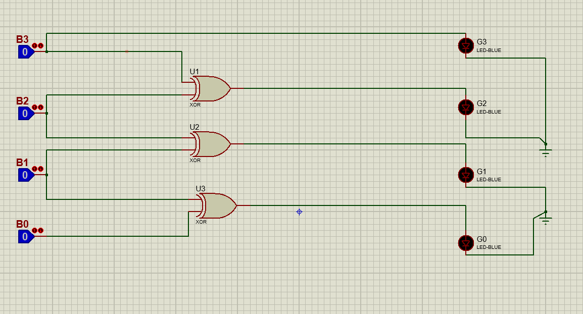
1:
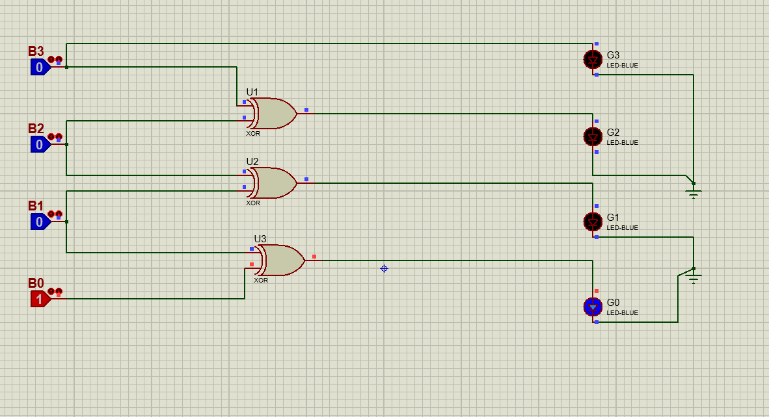

2:
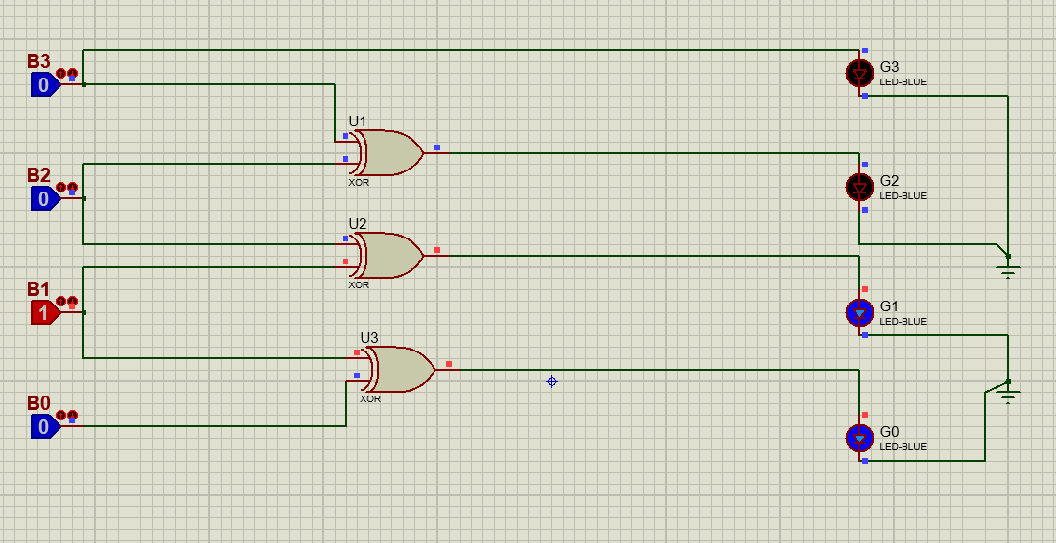
3:
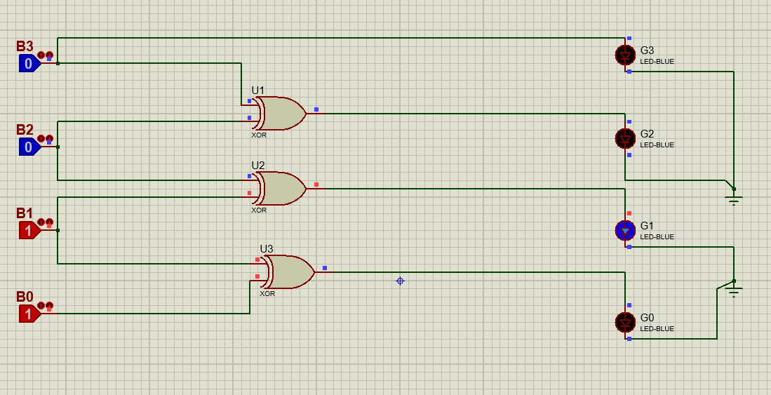

4:
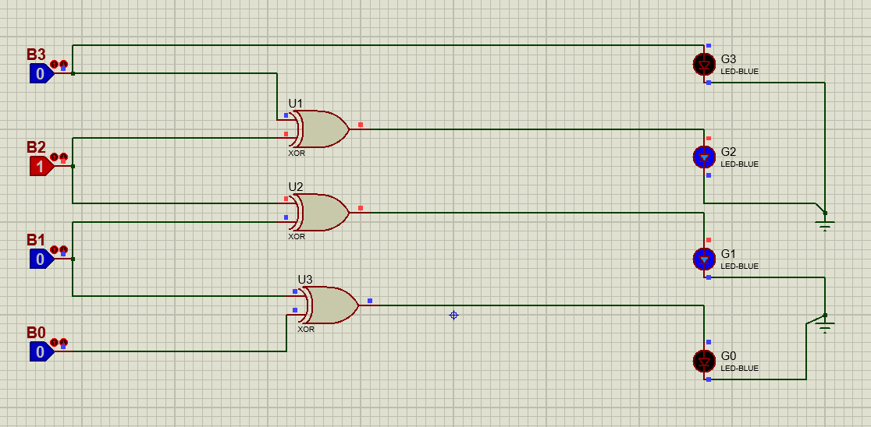
5:
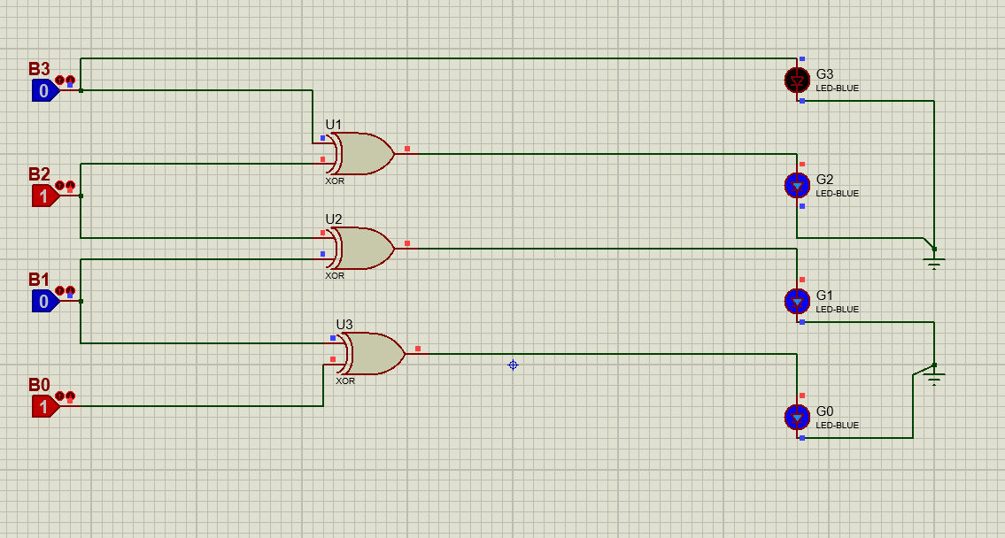

6:
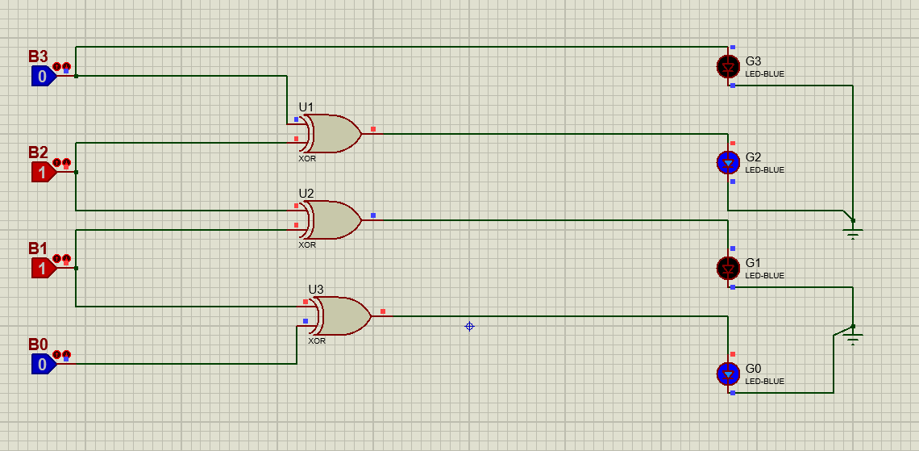
7: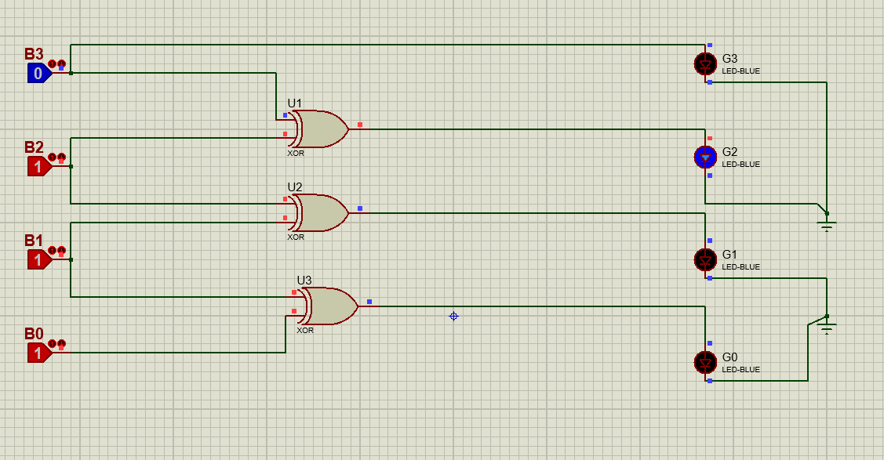
8: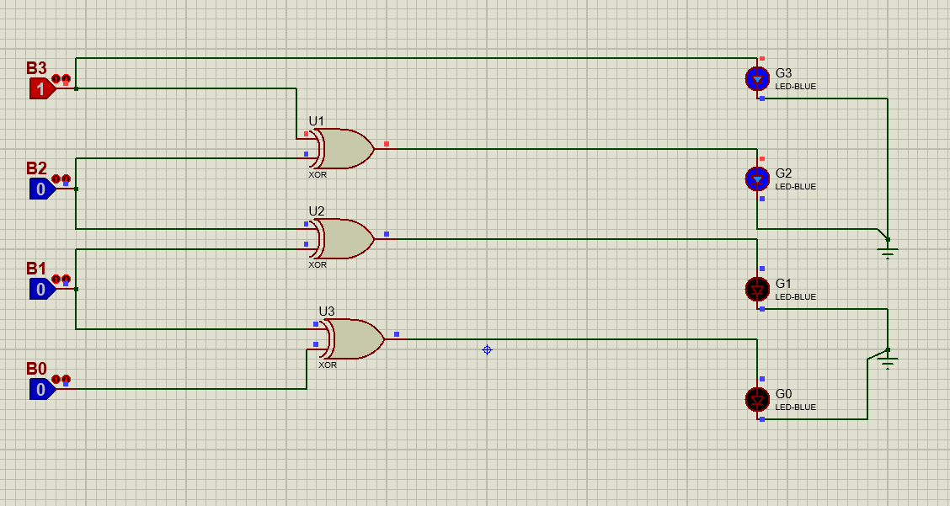
9:
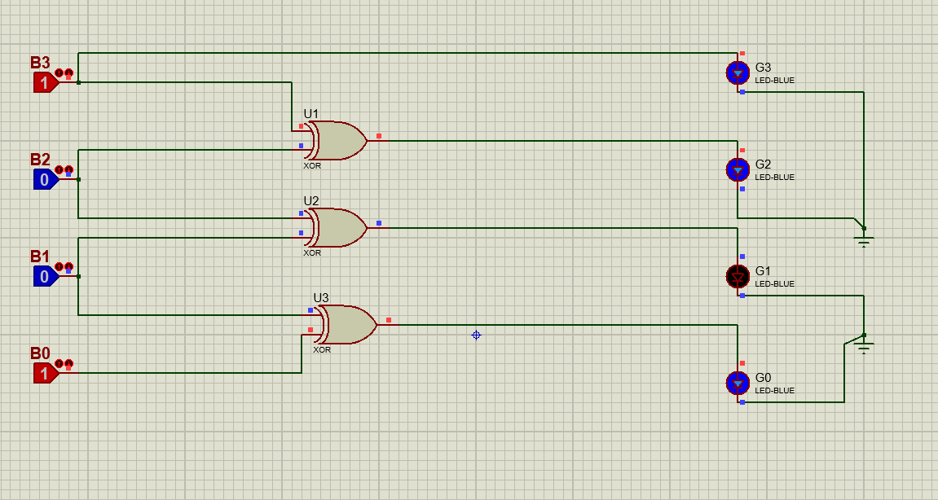

10:
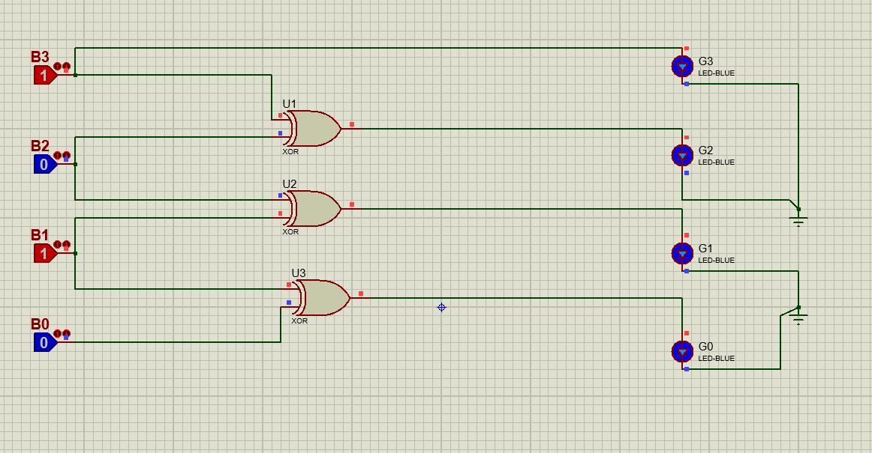
11: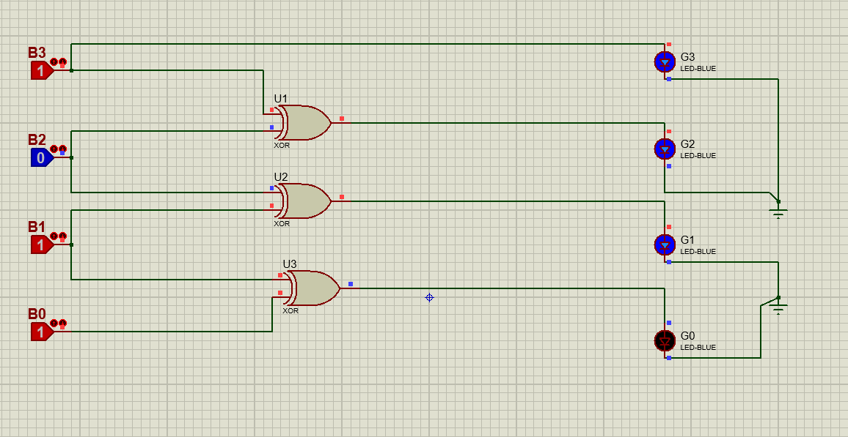
12: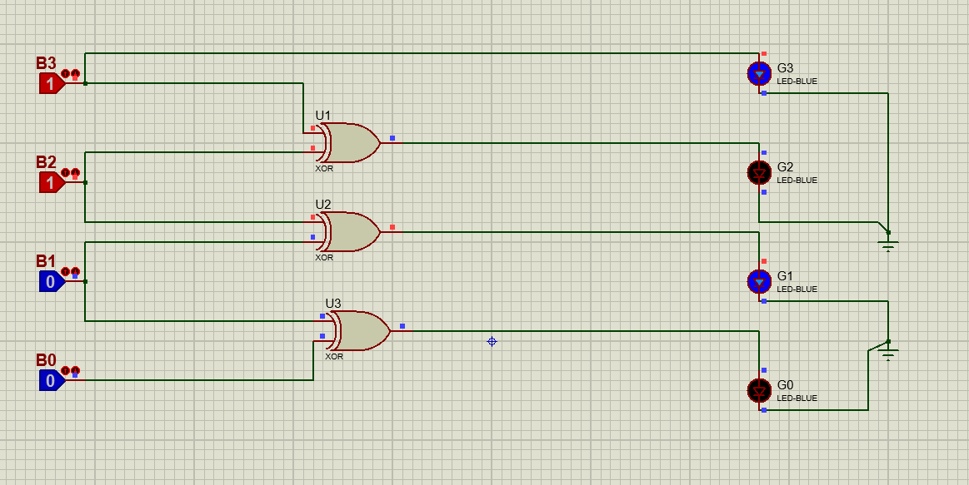
13:
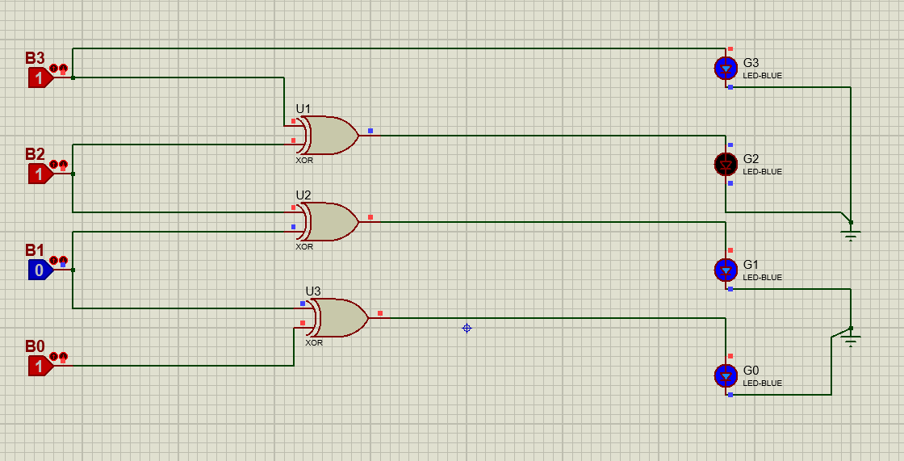
14: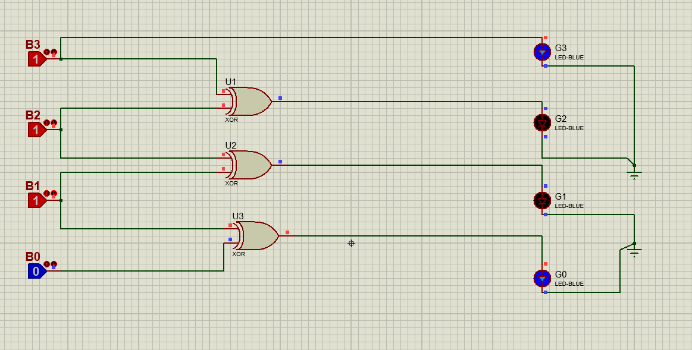
15: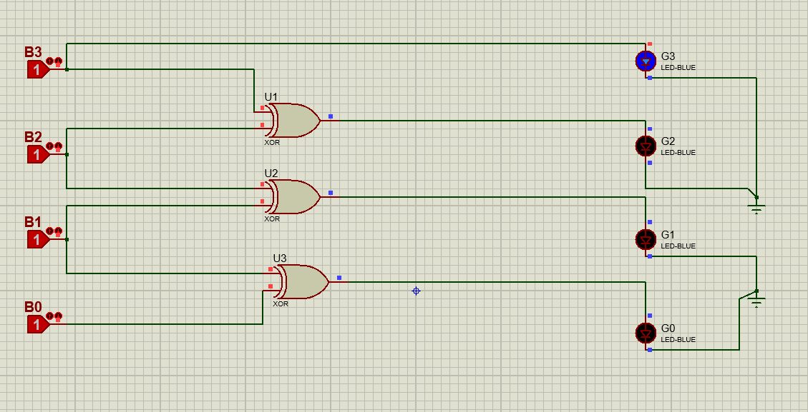

Conclusion:
The 4-bit Binary to Gray code converter was successfully designed and verified using XOR-based logic. The implementation was efficient, requiring only three XOR gates and one direct connection, without the need for K-map simplification.
Simulation results confirmed that the output matched the expected Gray code for different input combinations. The key property of Gray code, where only one bit changes between consecutive values, was also verified.
This lab demonstrated how logical relationships can be directly used to design optimized digital circuits and highlighted the importance of Gray code in reducing errors in practical systems.

